## GIT Whole Practice Assignment

Initialize a new repository for the project using Git.

**A:**Use git add command to stage a new file. Use “git commit” command with commit message to commit changes in the git repository. Check the status using “git status” command. Check commit history in Git Repository using git log.

**B:**Create an account in GitHub. Use git pull command to pull changes from GitHub

and git push command to push local changes into GitHub repository.

**C**:Create a feature branch in the git repository using git checkout –b command and modify the file. Commit the changes. Switch to the master branch. Use git diff command to view differences between master branch and feature branch. Use git difftool command to view differences in the p4merge tool.

**D**: Use p4merge tool to resolve the merge conflicts. Create Lightweight and Annotated tags for the commits. Create a branch from the stash using git stash branch command to move the changes to new branch.

1. **Initialize a new repository for the project using Git.**

Configure User Name & Email:

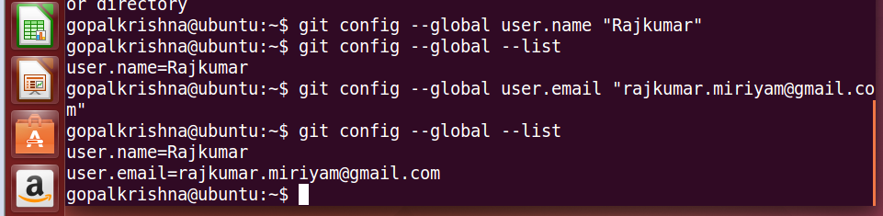

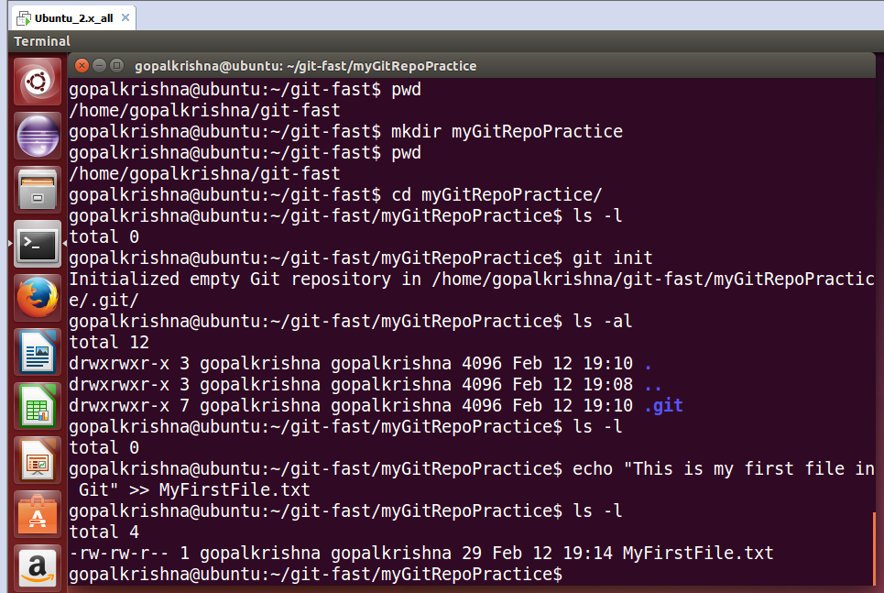

Converting un-versioned project to Git Repository:

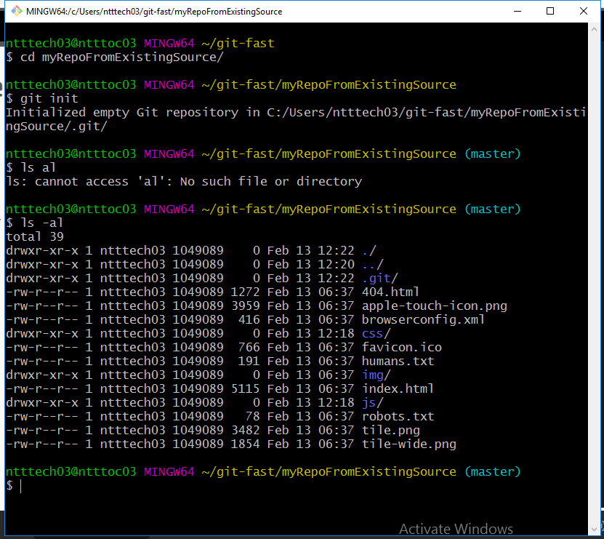

**A:**Use git add command to stage a new file. Use “git commit” command with commit message to commit changes in the git repository. Check the status using “git status” command. Check commit history in Git Repository using git log.

Created New File in the Project. Git status/add/commit/log commands.

1. git add -> It adds all changes to present directory.
2. git status -> It identifies the file changes before/after staging.
3. git commit –m “commit message” ->It commits the files/directories. It will create commit Id and ready to be push to repository.
4. git log ->It fetches and shows the list of commits (Commit History) done on the remote and local repositories.

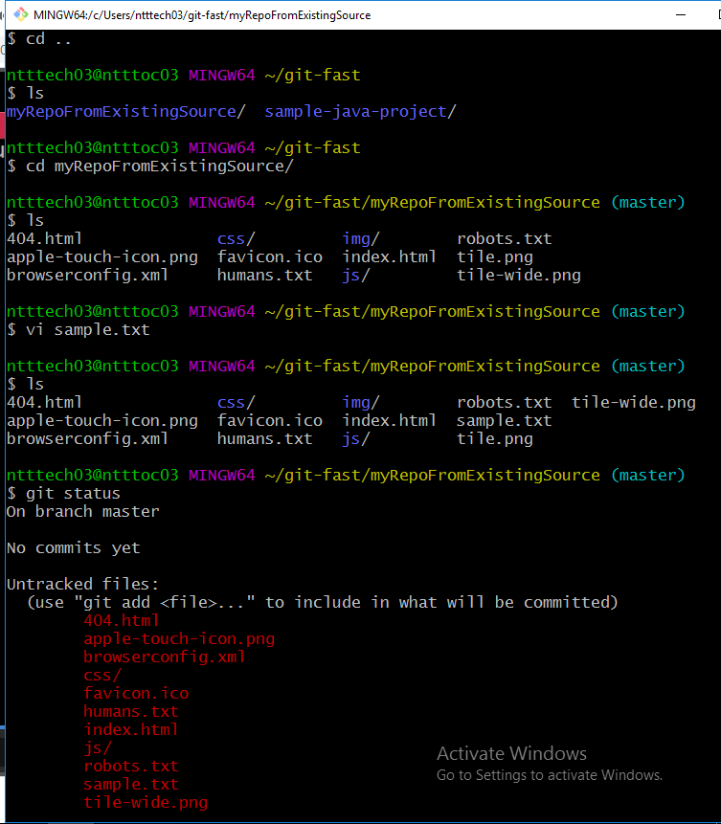

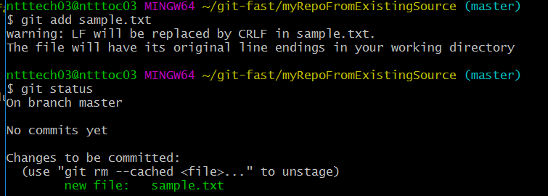

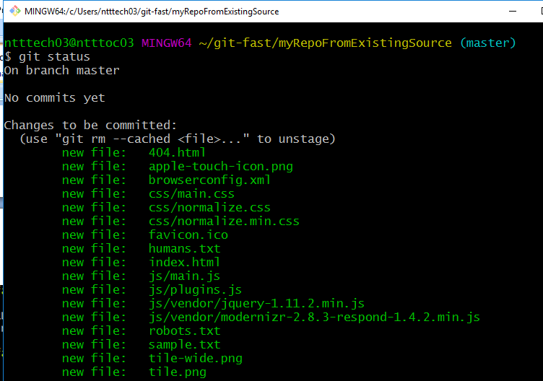

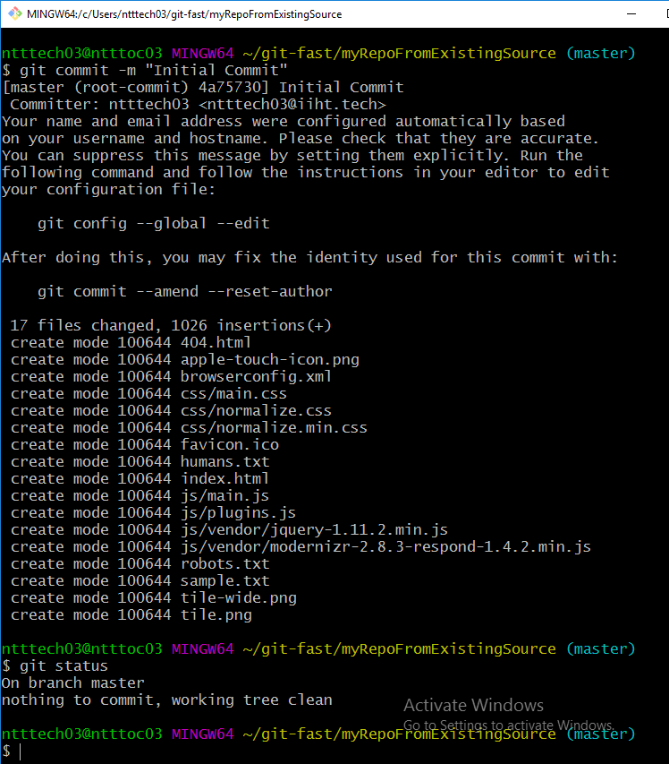

Checking Git History Log:

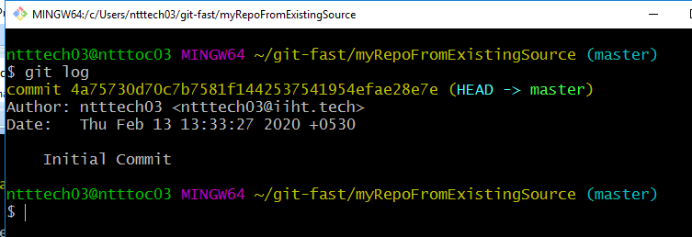

**B:**Create an account in GitHub. Use git pull command to pull changes from GitHub

and git push command to push local changes into GitHub repository.

Created an GitHub account.

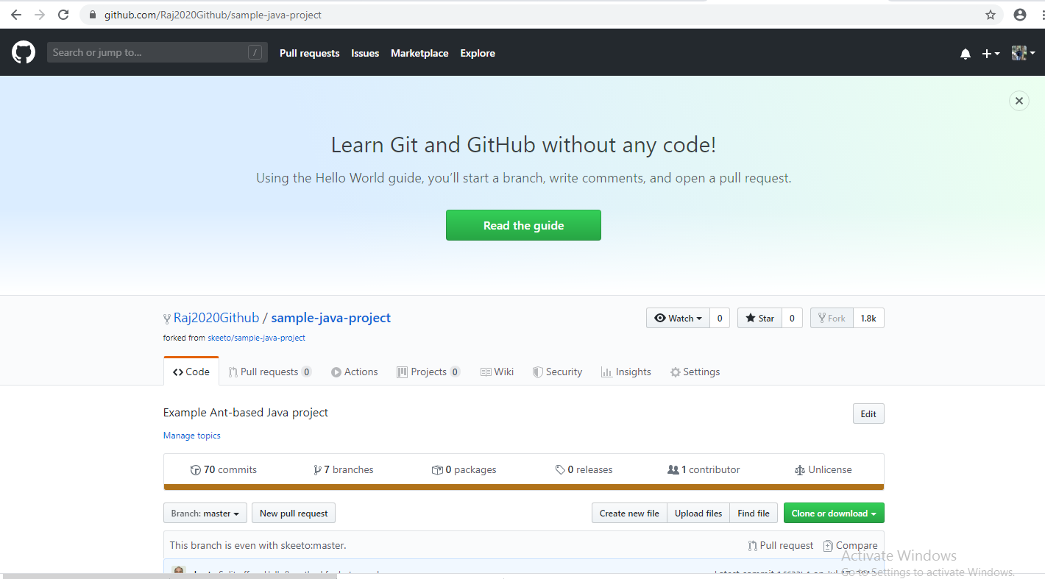

Clone the existing project from the Git Hub and do changes and Push the changes.

Clone: git clone <https://github.com/Raj2020Github/sample-java-project.git>

Push : git –u origin master

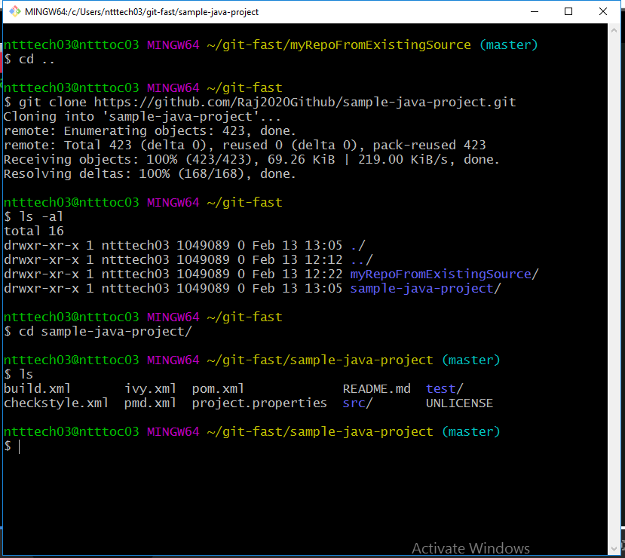

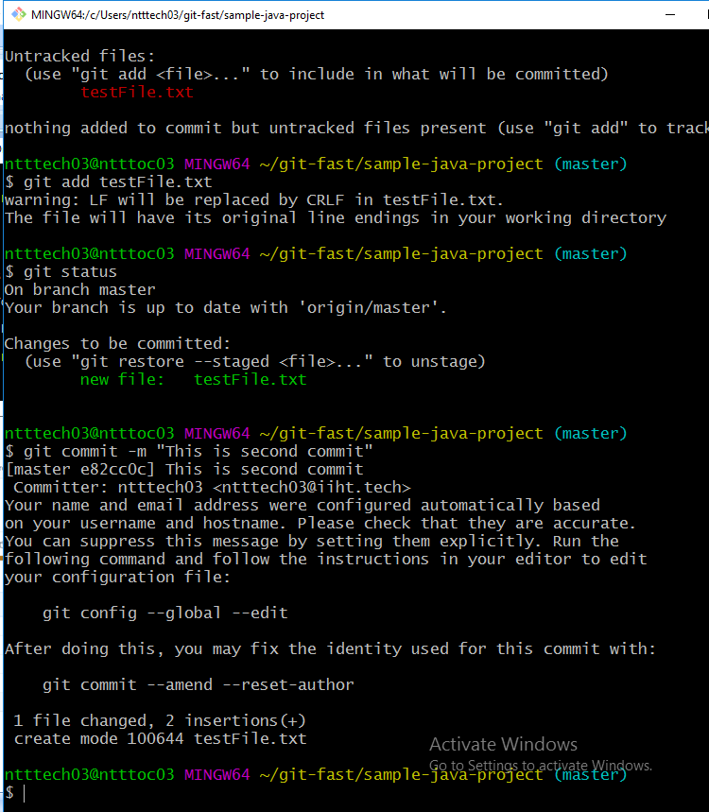

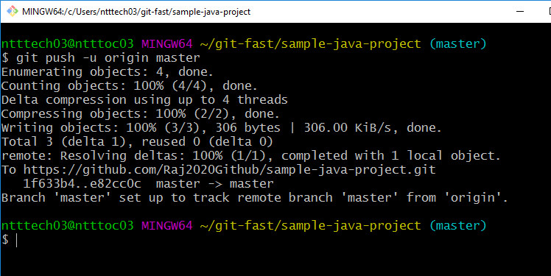

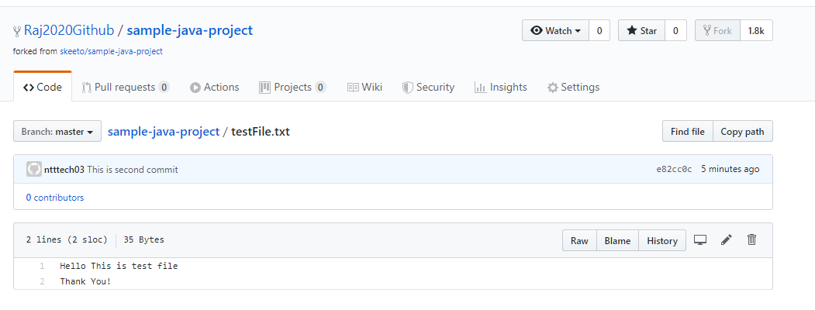

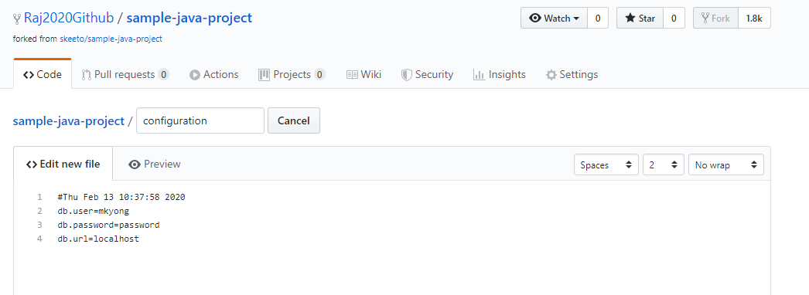

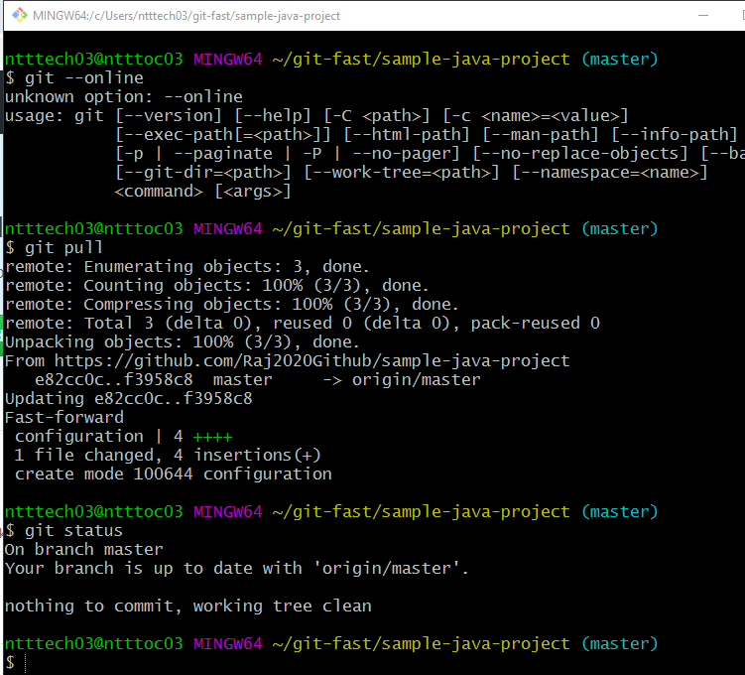

**C**:Create a feature branch in the git repository using git checkout –b command and modify the file. Commit the changes. Switch to the master branch. Use git diff command to view differences between master branch and feature branch. Use git difftool command to view differences in the p4merge tool.

Create a feature branch in the git repository

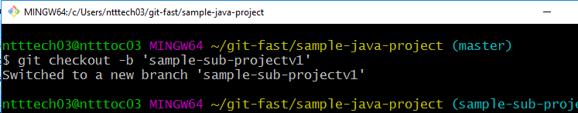

Update file and commit the changes in sub branch.

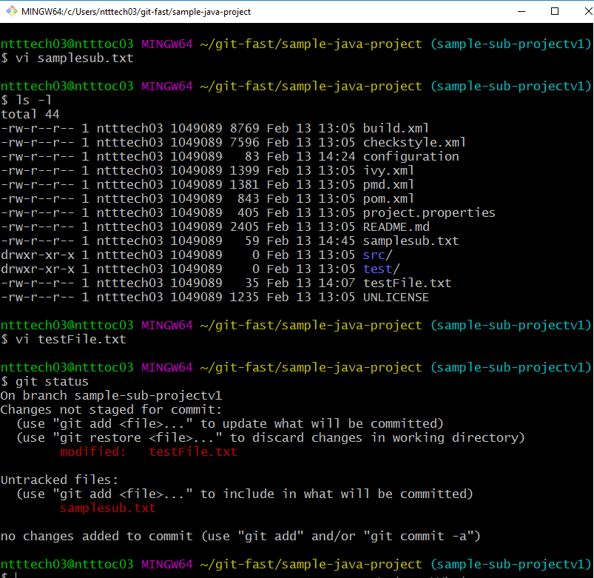

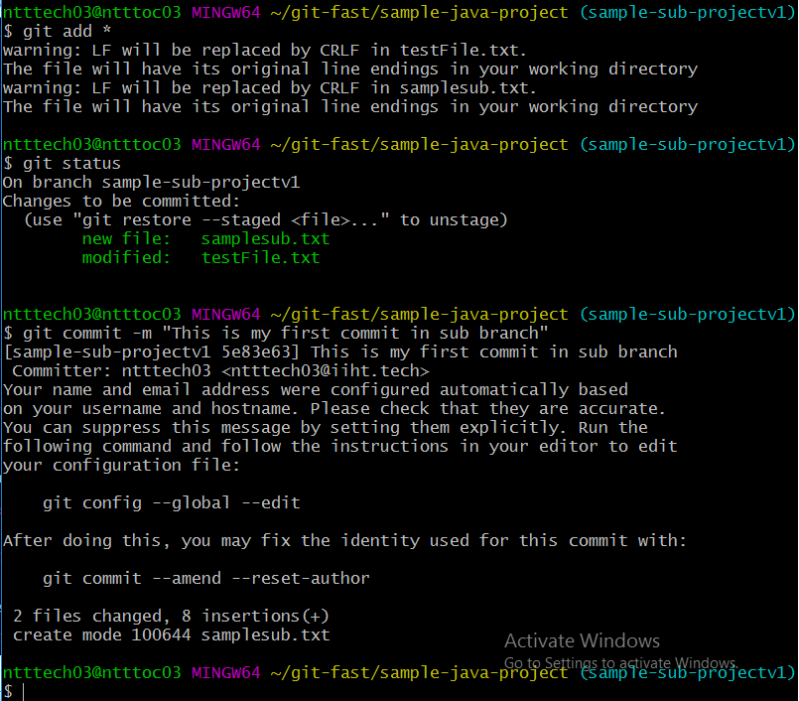

View differences between master branch and feature branch:

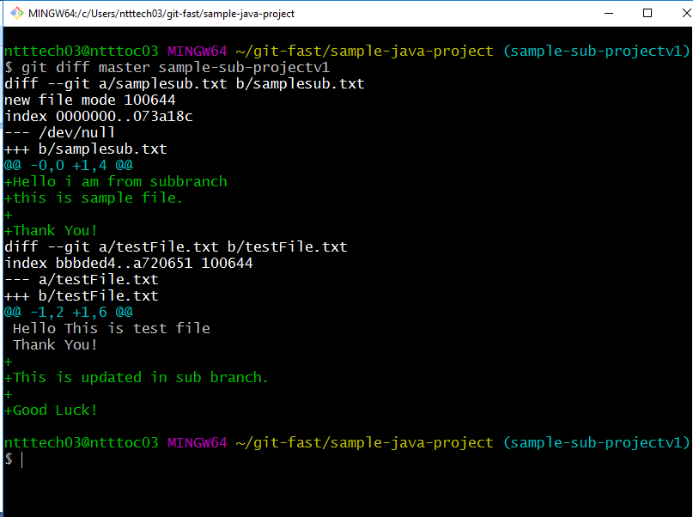

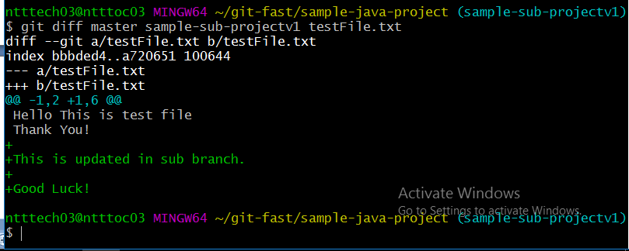

Switch to the master branch. Use git diff command to view differences between master branch and feature branch.

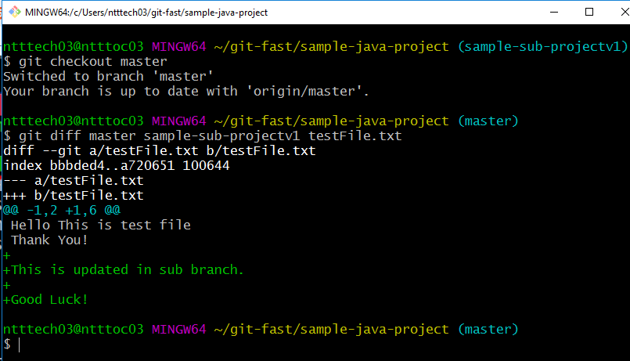

Use git difftool command to view differences in the p4merge tool.

Installed p4merge tool and configured.

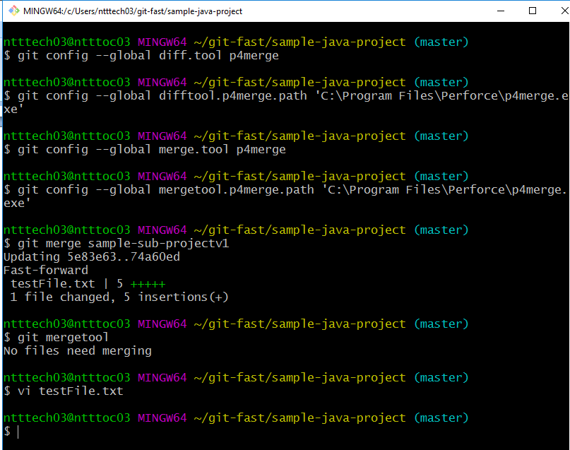

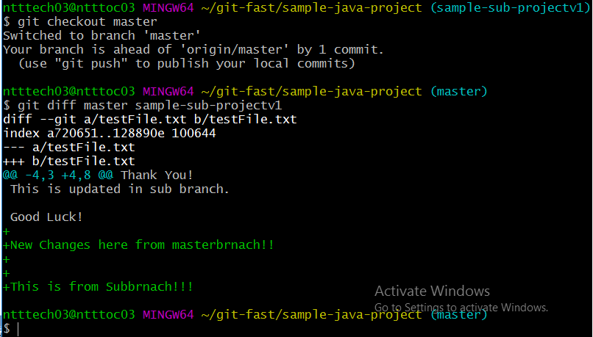

**D**: Use p4merge tool to resolve the merge conflicts. Create Lightweight and Annotated tags for the commits. Create a branch from the stash using git stash branch command to move the changes to new branch.

Merge conflicts and p4mergetool diff:

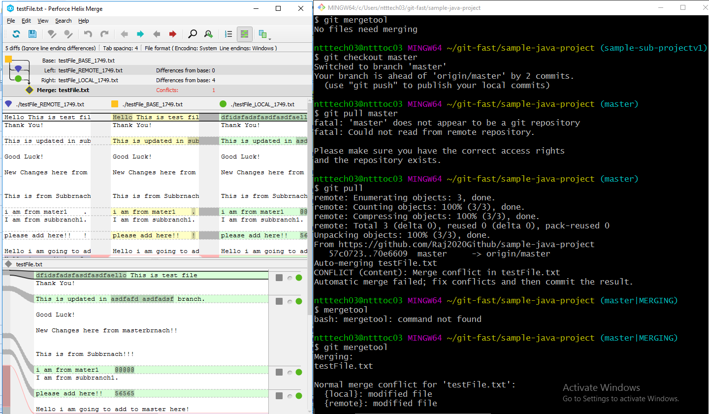

Commit changes after resolve conflicts and merge.

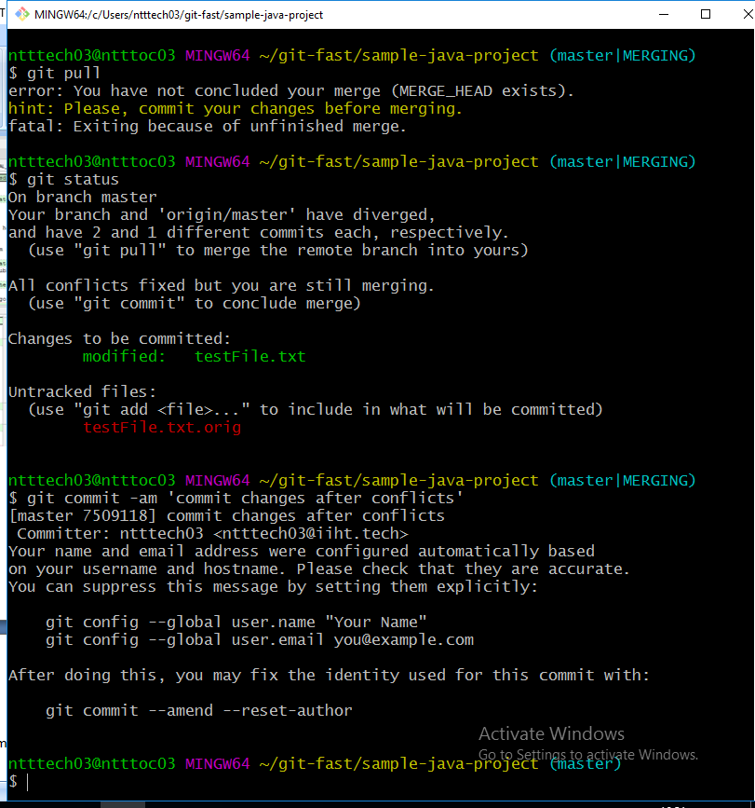

Create tag branch with latest commit of Master branch:

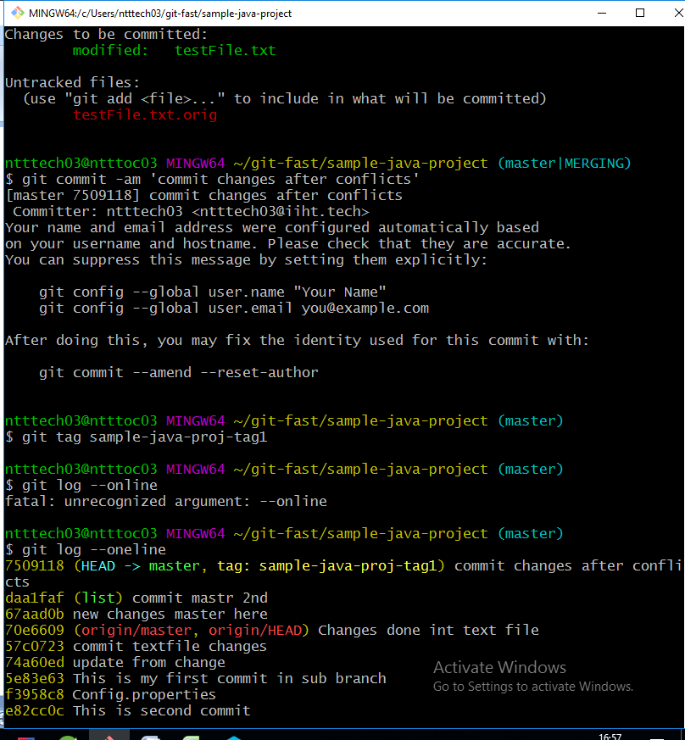

Changes made in master branch and commited.

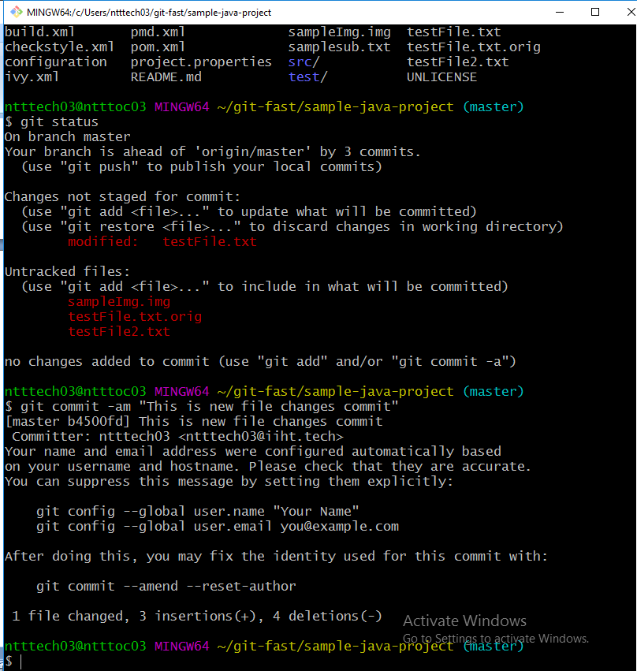

Created tag branch and committed with the tag comment.

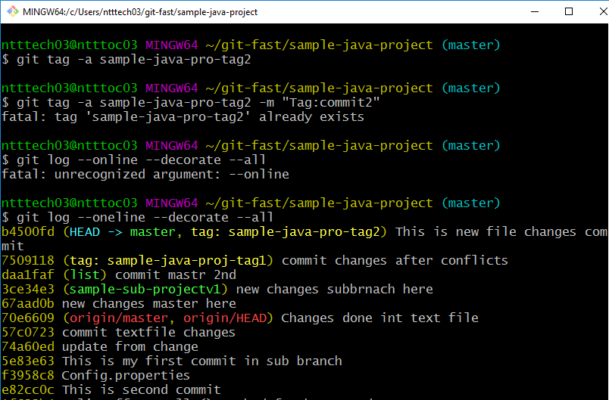

Create a branch from the stash using git stash branch command to move the changes to new branch.

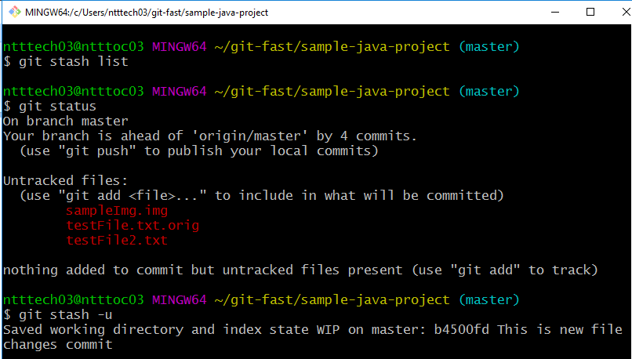

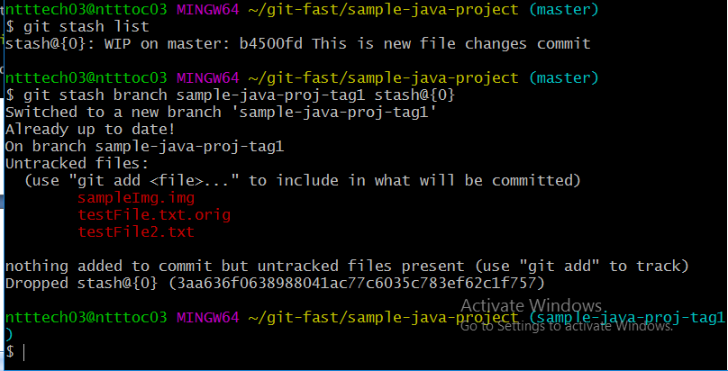

Adding existing code to Git Hub:

1. Create a repository in GitHub

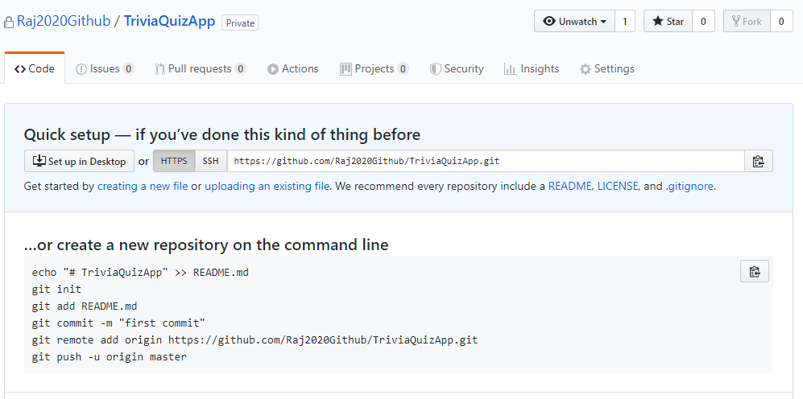

1. Go to existing project location and run GitBash

### Create a new repository on the command line

echo "# TriviaQuizApp" >> README.md

git init

git add README.md

git commit -m "first commit"

git remote add origin https://github.com/Raj2020Github/TriviaQuizApp.git

git push -u origin master

